# Basic Setup

1. download git <http://git-scm.com/download/win>
2. run and install, put git in your path
3. git –version=>בדיקה גרסה ככה גם אפשר לראות אם זה הותקן
4. git **config** --global user.name "Your Name"
5. git config --global user.email [youremail@example.com](mailto:youremail@example.com)

( הגדרות בסיסיות להגדרת שם משתמש ואימייל)

# D:\Dropbox\CodingAcademy\Cycles\CaMay17\Week6\GIT-Basics\GIT.png 1 - Local Repo

1. In your gallery folder, open command or terminal project
2. git **init**
3. Git **status**
4. git **add** .
5. Git status
6. git **commit** –m "My first commit!"
7. Git status
8. Git **log**
9. Modify a file שינוים
10. Git status
11. Git add .
12. Git status
13. git commit –m "Changed Something"
14. Git log

# 2 - Remote Repo

Now we want to synch our local repo with a remote repo (such as: github, bitbucket)

1. login or signup to github
2. create a new repo: git-ex
3. git **remote** add origin https://github.com/...
4. git remote –v
5. git push -u origin master
6. See your files in github
7. Go to settings and configure github pages=>setting->pages->change to main

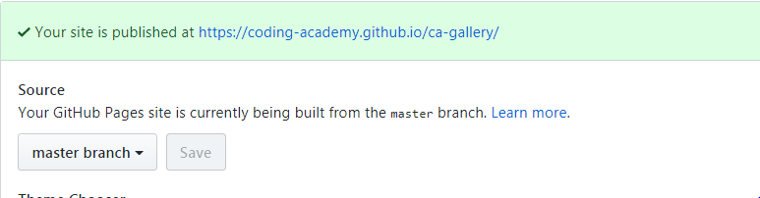

1. Your site is alive!

במידה ועשיתי עוד שיניים באתר אני שומרת אותם שוב ועושה את הפקודות הבאות

Git add .

Git commit -m "commit name"

Git push=>מעלה לגיטהאב

Cls=>מנקה מסך

**M** - Modified (An existing file has been changed)

**D** - Deleted (a file has been deleted)

**U** - Untracked (The file is new or has been changed but has not been added to the repository yet)

**C** - Conflict (There is a conflict in the file)

**R** - Renamed (The file has been renamed)

**S** - Submodule (In repository exists another subrepository)